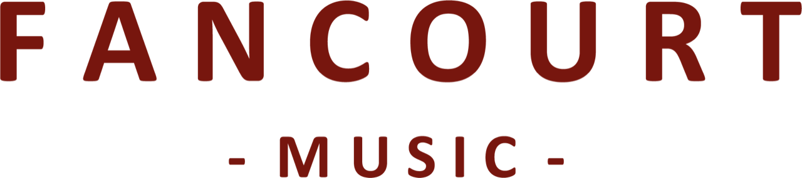

**JON DORAN & THE NORTHERN ASSEMBLY**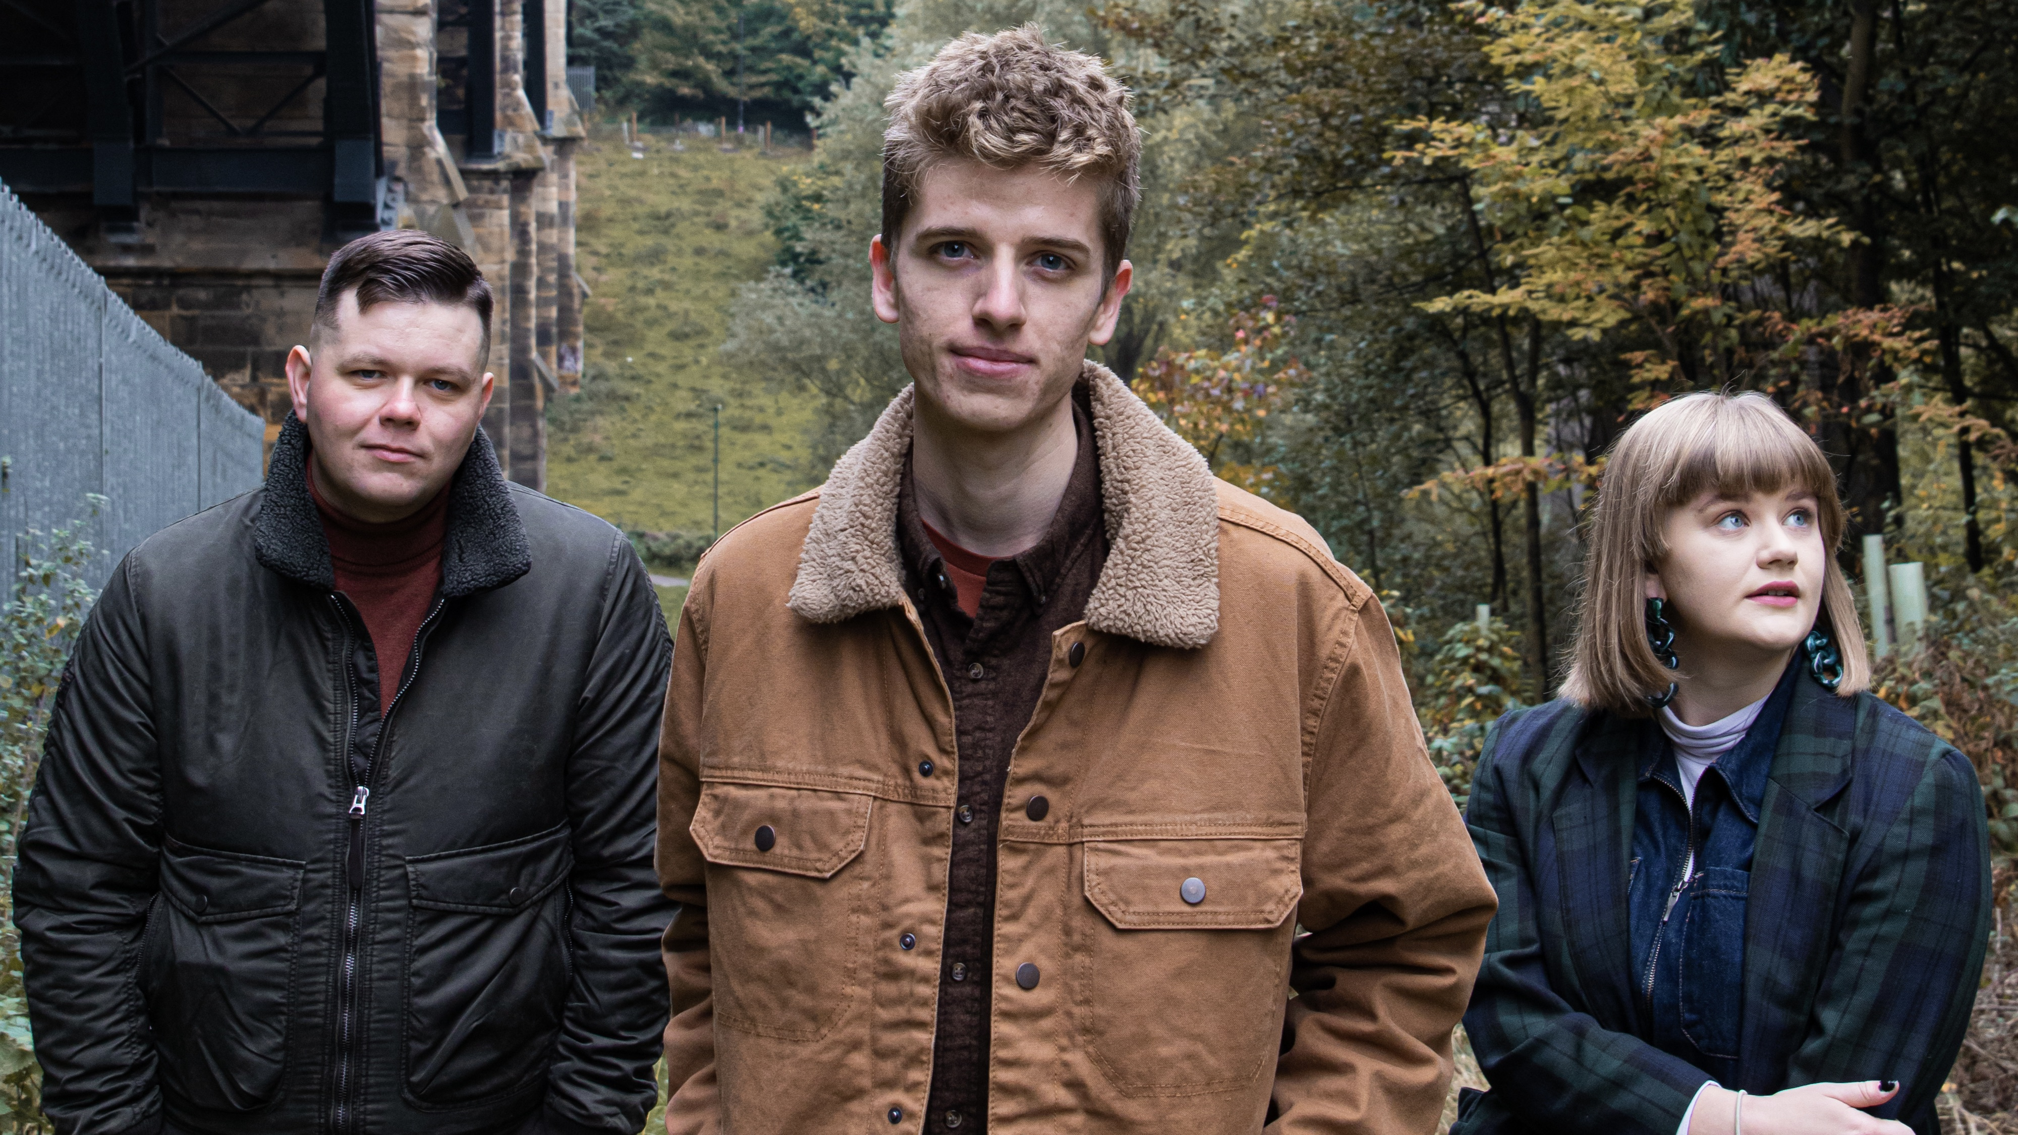

Jon Doran & The Northern Assembly are a groundbreaking new collaboration who seek to capture the excitement that lies within traditional song. The trio aims to breathe new life into old stories from across the British Isles, injecting the energy they feel these narratives

deserve.

With striking vocals from Jon Doran (BBC Radio 2 Young Folk Award Finalist 2019), combined with the virtuosic playing of Jordan Aikin (“trailblazer” - Calum MacCrimmon, Breabach), and Heather Ferrier (“accordion virtuoso” – Tom Robinson), the trio perform songs that create “a cohesive musical framework with intricately layered arrangements, each song from the traditional folk canon unfolding a vivid drama” (Folk London).

Their eponymous debut EP, released in 2024, gained an overwhelming amount of positive feedback and secured airplay on shows such as BBC Radio 2, BBC Introducing North East, and BBC Radio Lincolnshire. “Filled to the brim with energy, excitement and a lust for life” (TradFolk), the trio move away from a conventional folk-song performance style and lean heavily upon their varied musical upbringings and experiences to conjure emotions and communicate a story far deeper than the words of the song.

They blur the lines between two contrasting sides of the folk genre - the bright,

vibrant energy of contemporary instrumental folk music, and the intensity of traditional

storytelling songs. KLOF describe their songs as “overflowing with ideas for the production of imaginative, entertaining music”.

**“*The trio***’***s seemingly effortless mastery of vocals and instrumentation is truly impressive.”* Folk London**

**“*Absolutely beautiful”***

BBC Introducing North East

*For further information, please contact Lucy Shields at Fancourt Music*

*lucy.shields@fancourtmusic.com +44 7394 977176*